Assignment 1
1. Create a GitHub repository with the name dac-mar-24-<your prn>. Clone it on the local machine. Create a Hello World program Java program in the local repository directory. Push it to GitHub.

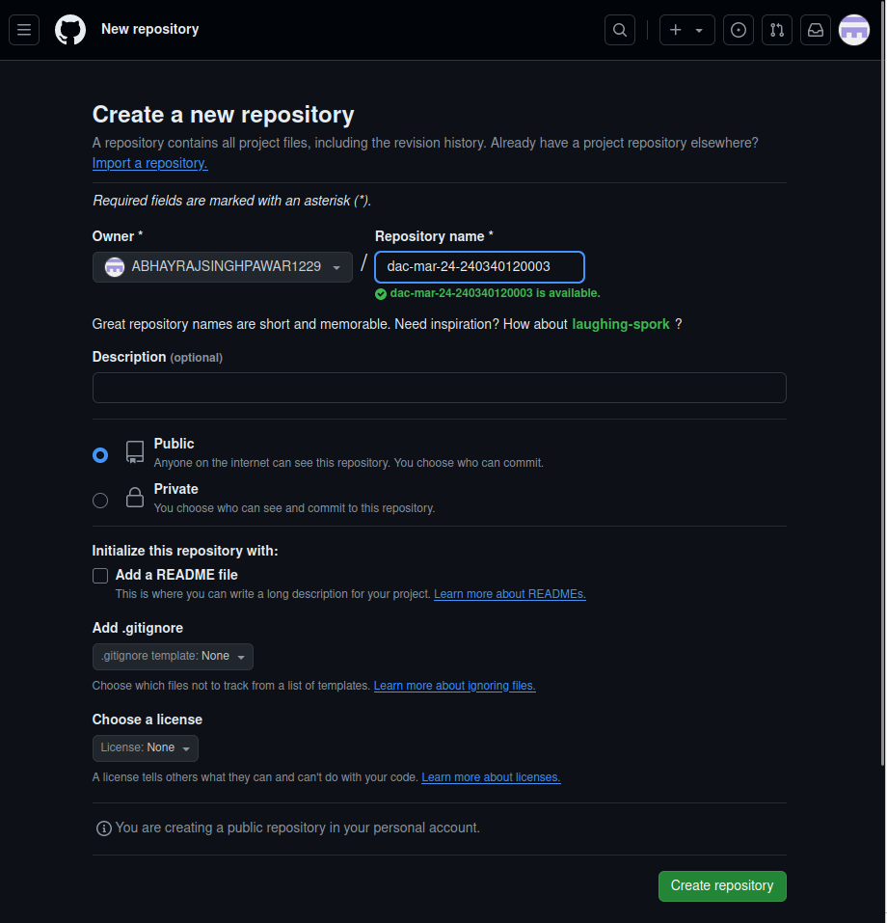

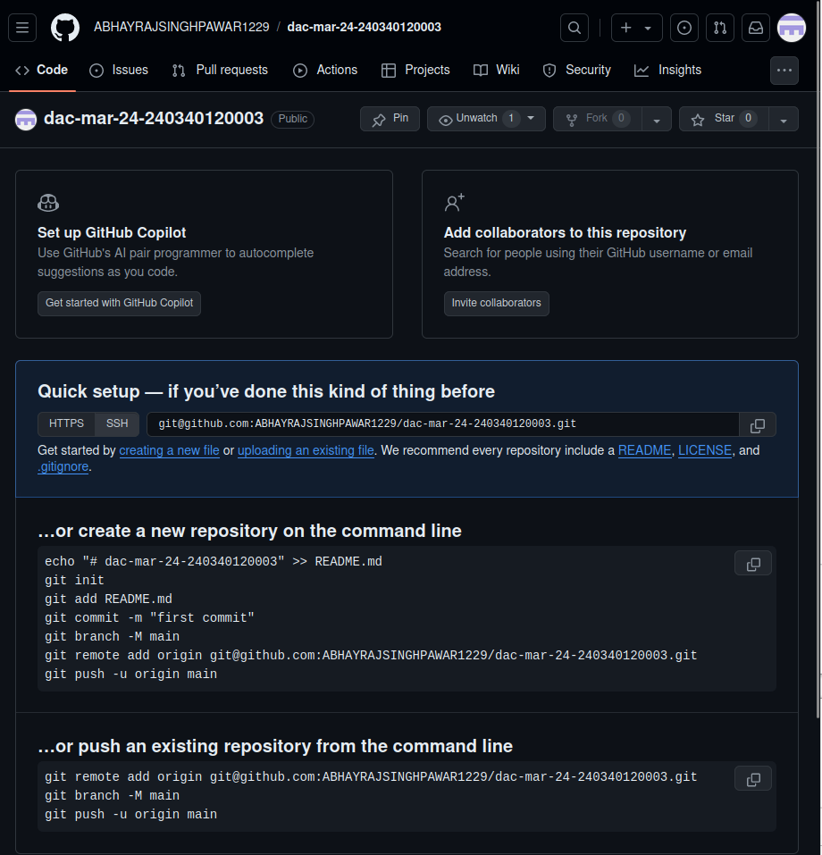

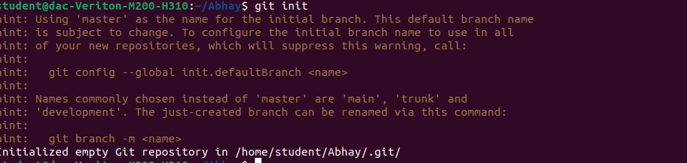

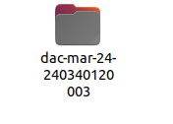

JAVA code in first branch
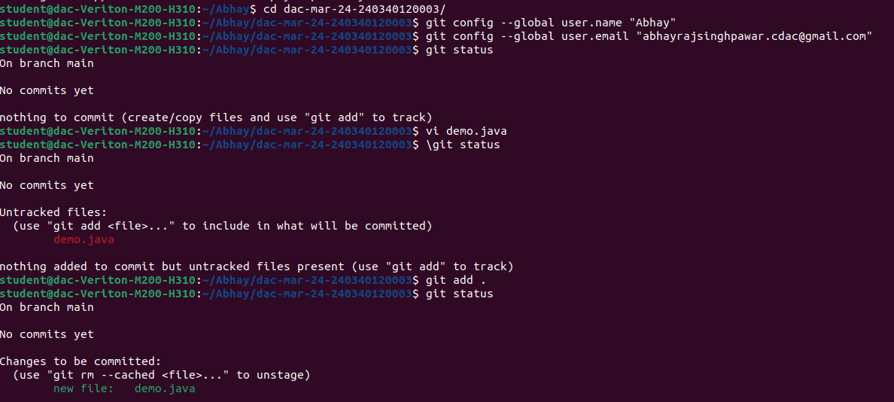

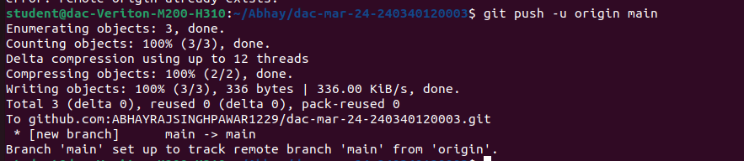
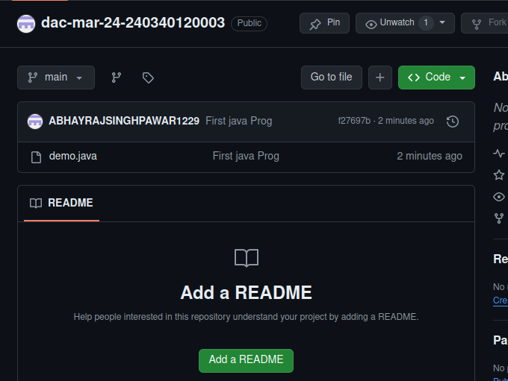

PYTHON code in master branch
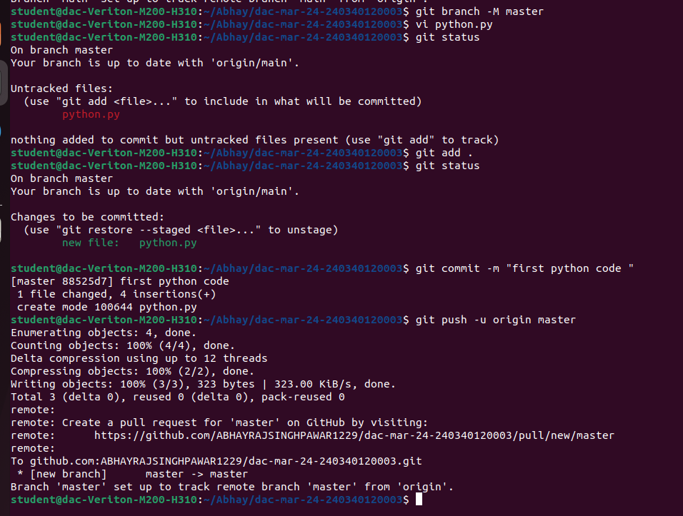

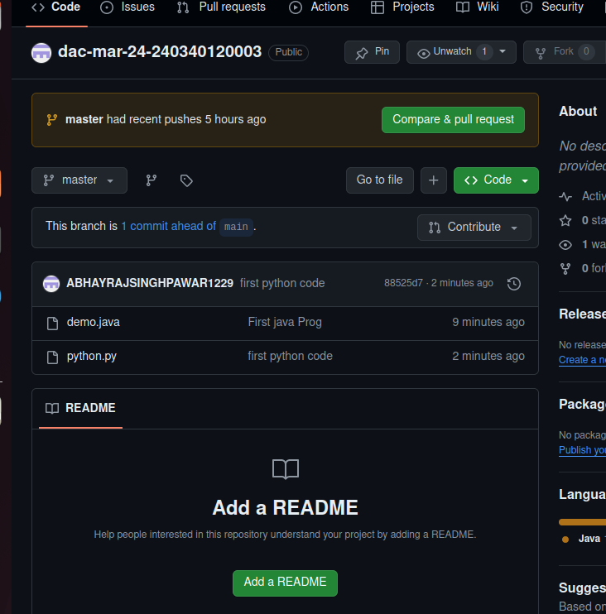

2. Create two branches B-1 and B-2. Make changes to the HelloWorld.java file in both the branches. Merge them and finally keep only the main branch. Push the final version to GitHub.

JAVA code in first branch

PYTHON code in master branch

Merging of two branch

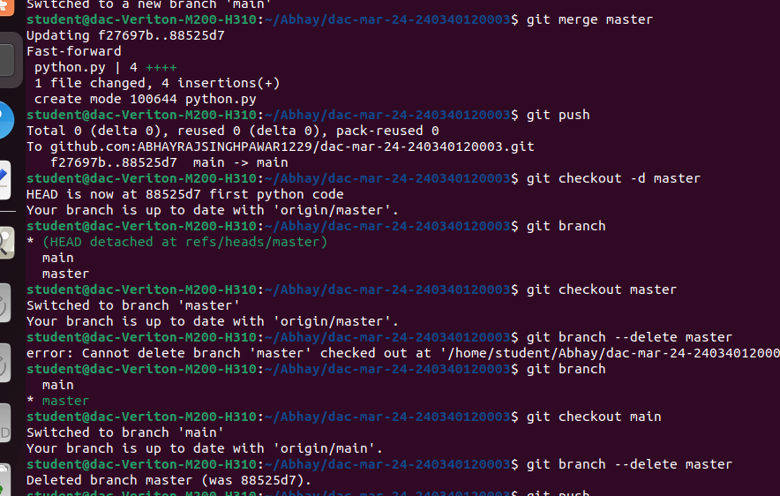

3. Create a Hello World Docker Java image. Push it to DockerHub as version 1.
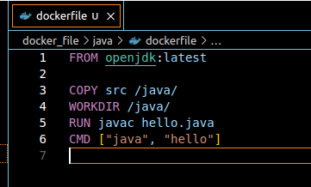

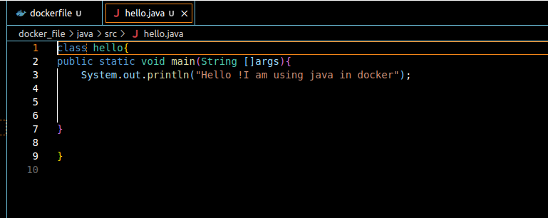

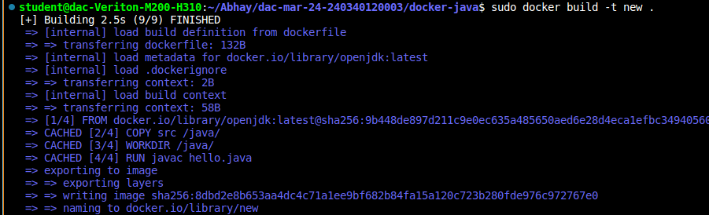

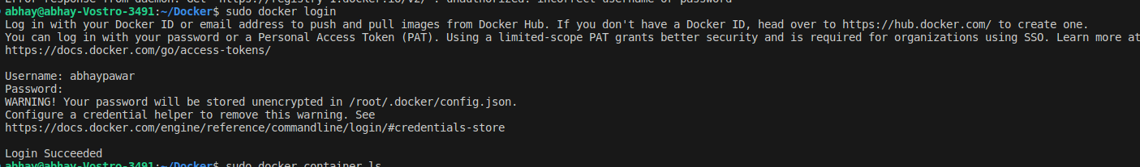

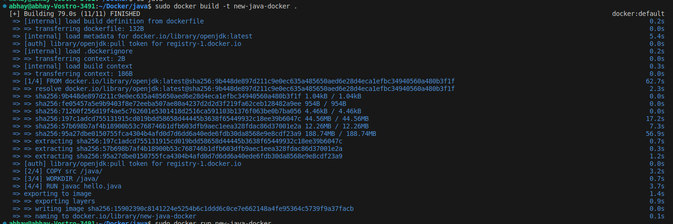

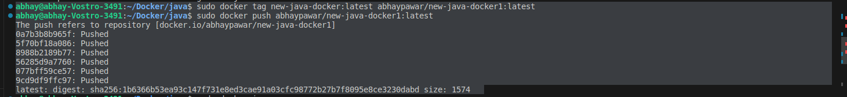

4. Add two more lines to the Hello World program:
This is from C-DAC ACTS ...
We are in DAC ...

Push version 2 of the same Docker image to DockerHub.

